Num Zero

1. The test fails because the for loop starts at 1 and hasan unexpected set of number leading to a correct number count.
2. 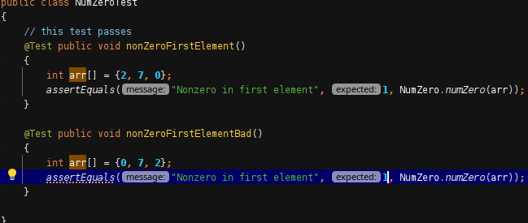
3. 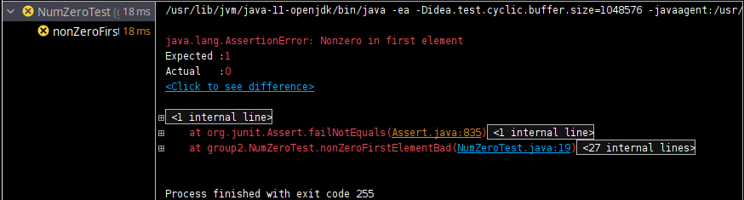

ColorPoint

1. The test fails because the specific values that are used to check for transitivity don’t account for the symmetry and transitivity is not being respected in this situation.

p.equals(cp2) is always true

if cp1.equals(p) && p.equals(cp2) are true then cp1.equals(cp2)

1. 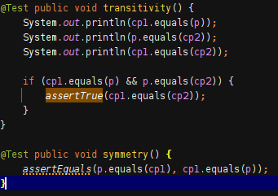
2. 

CloneTest

1. The test fails for Truck because it has a class cast exception even when you are replicating the same idea as you used for the vehicle.
2. 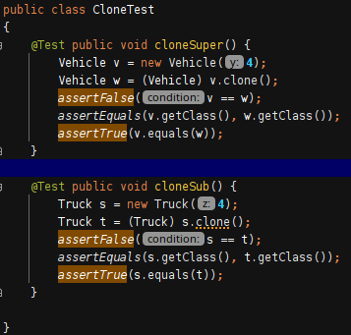
3. 

BigDecimalTest

1. When adding to the tree initially it has one element, when you hash add the tree now has two elements and due to this fact the assertion cannot be true. When changing 1.0 to 1.00 it reveals that value is expected.
2. 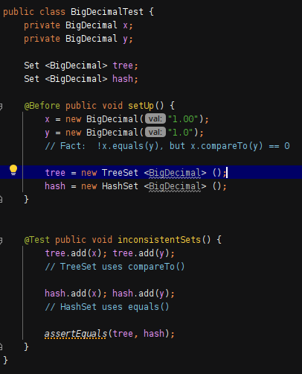
3. 